AI LAB ASSIGNMENT-4.1
ROLL NO.: 2403A52400
BATCH NO.:14
COURSE NAME: AI ASSISTED CODING
>Task #1 – Zero-Shot Prompting with Conditional Validation
Objective
Use zero-shot prompting to instruct an AI tool to generate a function that validates an Indian mobile number.
Requirements
- The function must ensure the mobile number:
  - Starts with 6, 7, 8, or 9
  - Contains exactly 10 digits
Code:
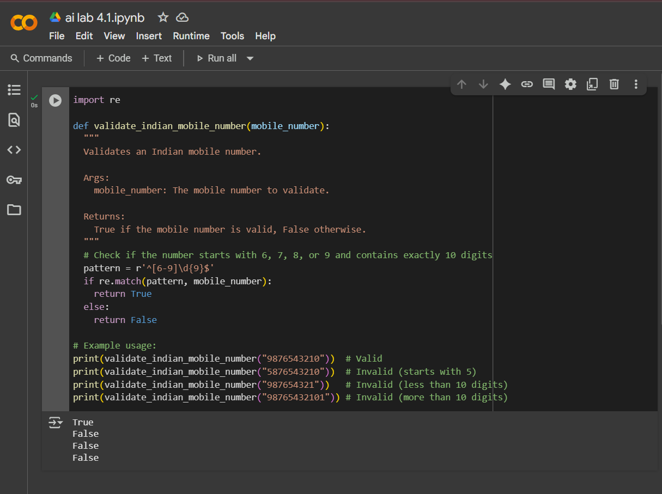

>Task #2 – One-Shot Prompting with Edge Case Handling
Objective
Use one-shot prompting to generate a Python function that calculates the factorial of a number.
Requirements
- Provide one sample input-output pair in the prompt to guide the AI.
- The function should handle:
  - 0! correctly
  - Negative input by returning an appropriate message

Code:
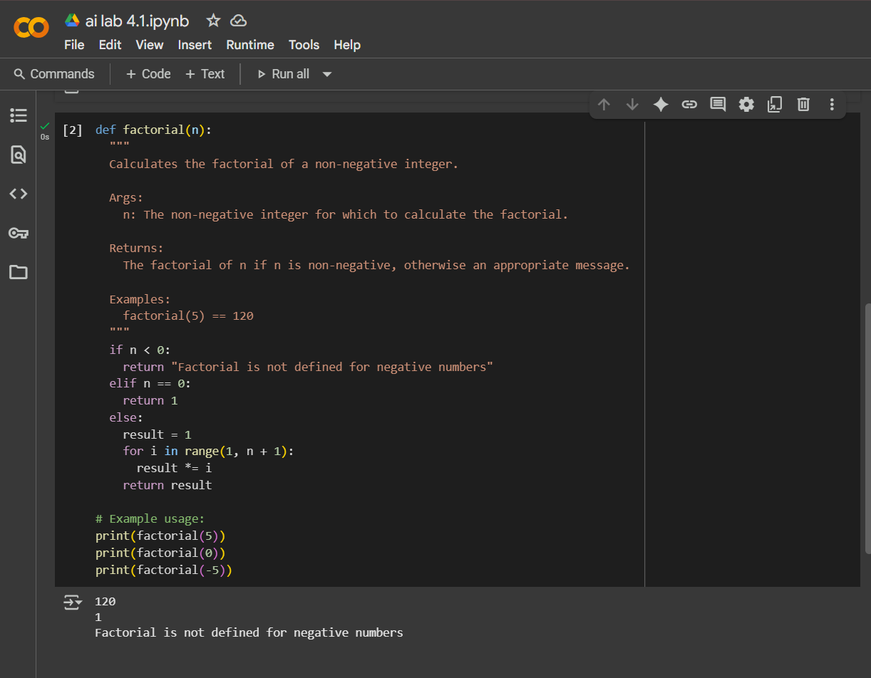

>Task #3 – Few-Shot Prompting for Nested Dictionary Extraction
Objective
Use few-shot prompting (2–3 examples) to instruct the AI to create a function that parses a nested dictionary representing student information.
Requirements
- The function should extract and return:
  - Full Name
  - Branch
  - SGPA

CODE:
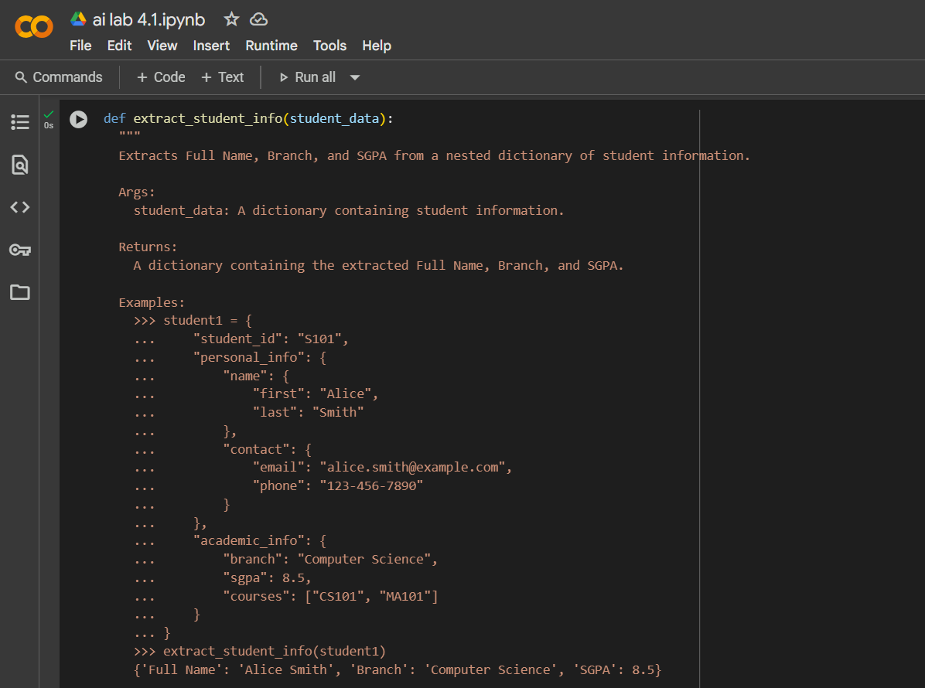
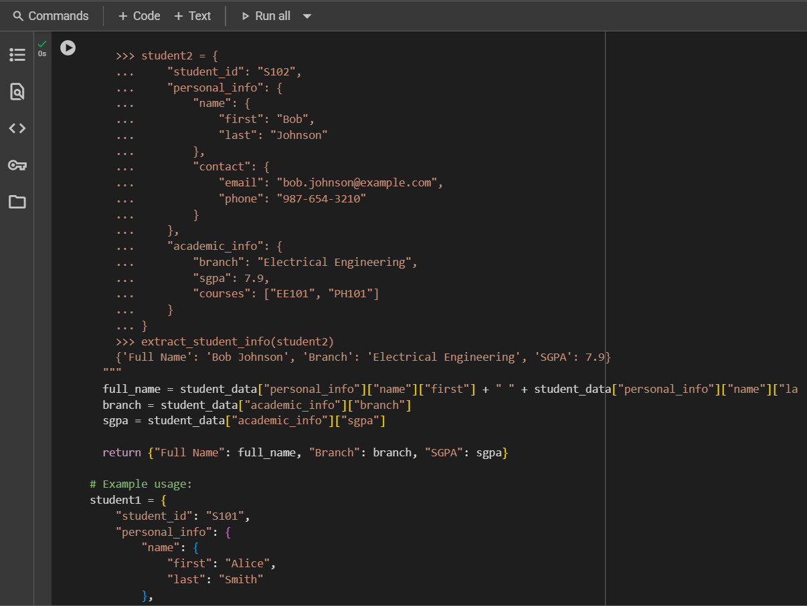
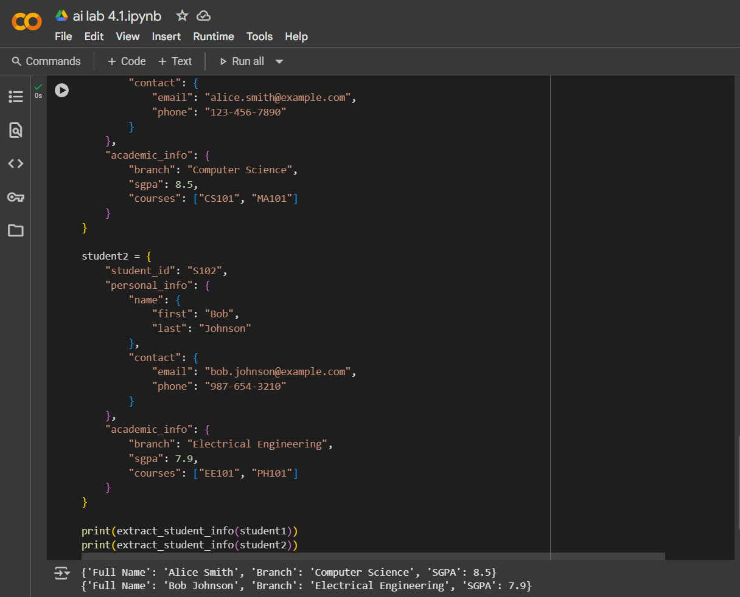

>Task #5 – Few-Shot Prompting for Text Processing and Word Frequency
Objective
Use few-shot prompting (with at least 3 examples) to generate a Python function that processes text and analyzes word frequency.
Requirements
The function must:
- Accept a paragraph as input
- Convert all text to lowercase
- Remove punctuation
- Return the most frequently used word
Code:
